MILFORD ROTARY CLUB

SEVENTH ANNUAL

Flags for Heroes

Memorial Day 2021

Corporate & Foundation
Sponsorship

The proceeds from Flags for Heroes have been used for many purposes including:

- Purchase dictionaries for all third graders in the Milford School District
- Support the Milford High School Music programs
- Send students to Rotary Youth Leadership Academy
- Send campers to Easter Seals Camp Fairlee Manor
- Assist Milford Community Food Pantry
- Assist Milford Parks & Recreation Department
- Contribute to Rotary Polio Plus to eradicate polio worldwide
- Provide scholarships to graduating seniors residing in greater Milford
- Contributions to other service club events, local non-profit organizations and to those in need

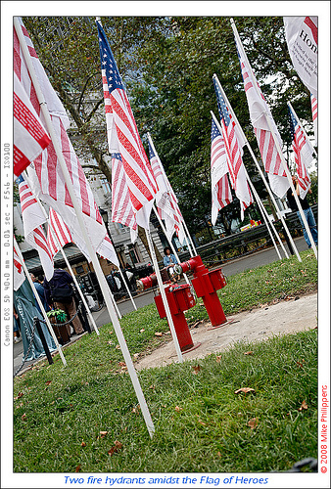

Each American-made flag will be displayed in Milford’s Bicentennial Park between May 25-June 10, 2021,
with a plaque identifying the donor and the Hero. The public will be invited to view the flags and pay respect to those honored. If you have questions, contact:
Gary Downes (302) 745-7697
Jack Donovan (302) 422-1802
David Rutt (302) 424-2240
Robert Starkey (302) 422-0108

CORPORATE & FOUNDATION SPONSORSHIP

STARS AND STIPES LEVEL 1. 100 Flags OLD GLORY LEVEL 1. 50 Flags
$5000 2. Banner at site naming your $2500 2. Banner at site naming your
company on field of honor. company on field of honor.
3. 100 names of heroes listed 3. 50 names of heroes listed.
4. Company named in ad in paper. 4. Company named in ad in paper.
5. Dinner with Rotary honoring you. 5. Dinner with Rotary honoring you.

GRAND OLD FLAG 1. 25 Flags RED LEVEL 1. 10 Flags
$1000 2. Banner at site naming your $500 2. Heroes named
company on field of honor.
3. 50 names of heroes listed.
4. Company named in ad in paper.
5. Dinner with Rotary honoring you.

WHITE LEVEL 1. 5 Flags BLUE LEVEL 1. 3 Flags
$250 2. Heroes named $150 2. Heroes named

I would like to become a Corporate/Foundation sponsor
Sponsorship Level: _____________________________
Total cost: _____________________________
Organization Name: _______________________________________________________
Contact Person: _______________________________________________________
Address: _______________________________________________________
E-mail address: ________________________________________________________
Attach names of Heroes or designate by May 18, 2021 to assure plaques:
[One Hero per Flag]
___________________________________________________________________________________________________________
Rotarian: ___________________________________________________________________________________________________________

Make checks payable to: The Milford Rotary Club Educational Foundation, P.O. Box 10, Milford, DE 19963-0010. One check may be written for
multiple corporate sponsorships. Your contribution is tax deductible. Proceeds go to support Rotary’s community programs and scholarships.

